**Convective radiative plane Poiseuille flow of shear-thinning fluid through porous medium**

**( towards the Development of Sensor for diagnosis of Vitamin-D )**

Project report submitted

in partial fulfillment of the requirement for the degree of

**Bachelor of Technology**

**By:**

**Chammandi Ravi Kiran & Vikash Nirwan**

**(190103028, 190103121)**

**Under the Supervision of**

**Dr. Pranab Kumar Mondal**



**DEPARTMENT OF MECHANICAL ENGINEERING**

**INDIAN INSTITUTE OF TECHNOLOGY GUWAHATI**

**( November 2021 )**

**Abstract**

The plane poiseuille flow of shear-thinning fluid (Carreau model is considered). A set of governing equations are taken and converted into dimensionless form for the analysis. The starring role of heat transfer, magnetic field and porosity are all together taken into account. The effectual reliability of analytical solutions derived by homotopy analysis method is verified through various graphs. Impact of physical factors is examined via graphs.

**Table of Contents**

**1.** Introduction…………………………………………………. 4

1. Literature Review…..………………………………………. 5

1. Problem Formulation………..………………………...…… 7

1. Solution…………………………………………………….. 14

1. Results …………………………………………………….. 16
2. Conclusion………………………………………………..… 19
3. Future Work ………………………………………………. 20
4. References ……………………………………………….. 21

**Introduction**

Flow held within two opposite plates at a fixed distance due to pressure difference i.e., plane Poiseuille flow has gained great importance in many industrial processes. The constitutive relation of power law fluid is uncomplicated but it cannot accurately predict viscocity for extremely high or low shear rates. So, to overcome this limitation, Carreau model is considered as it can retain at high and low shear rates unlike power law fluid. Carreau fluid has the ability to reveal the rheology of multiple specific fluids such as fluids with brief-chain suspension particles, detergents, fluid crystals, and blood in humans and animals. This model has gained a notable attention due to its significance in extrusion of a polymer, tumors treatment, bitumen for road construction, cosmetics, etc. Convective fluids have industrial and potential application, such as in power generation, cooling of electronics devices and nuclear reactors at the time of emergency, heat exchangers, chemical processes, and many other cooling or heating processes. The investigation of mixed convection in Poiseuille flow in a channel has gained unimaginable significance because of its utilization in the geophysical framework, film vaporization in ignition chambers, nourishment handling and capacity, rocket rooters, warm protection, electrochemistry, the cooling arrangement of electronic gadgets and synthetic response in designing. The fluid flow of various types involving the thermal transfer in a porous medium have been the center of attraction for many scientists due to physical applications, which includes crude oil extraction, fiber insulation, and storing the waste of radioactive nuclear, etc. Thermal radiation is also considered. For analytical solution of formidable governing equations are achieved by a well-known technique called homotopy analysis method (HAM).

**Literature Review**

The convective radiative plane poiseuille flow of nanofluid through porous medium with slip under influence of Stefan blowing is studied by S.Z.Alamri et al. [1]. They have considered the poiseuille flow of a nanofluid through a porous medium under the influence of Stefan blowing. In this paper we have extended this to a shear thinning fluid ( Carreau Model ). For the Carreau shear thinning model, we have taken Flows of Carreau fluid with pressure dependent viscosity in a variable porous medium: Application of polymer melt by M.Y.Malik et al. [2] and Pipe flow of shear-thinning fluids by S.N.López-Carranza et al. [3] as reference for writing governing equations for our problem. In [2], they have studied a flow of Carreau fluid with pressure dependent viscosity in an inclined channel of height h. In [3], they have studied the flow of a purely viscous shear-thinning fluid in a circular pipe of radius R. Structural impact of kerosene-Al2O3nanoliquid on MHD Poiseuille flow with variable thermal conductivity: Application of cooling process is studied by R.Ellahia et al. [4]. In [4], they have studied the cooling process by means of kerosene-Al2O3 nanoliquid on MHD Poiseuille flow with variable thermal conductivity in which they have also considered magnetic field.

**Nomenclature**

$V$: Velocity vector

P : Pressure Gradient

$μₒ$: Zero shear rate viscosity

$μ_{∞}$: Infinite shear rate viscosity

$\dot{γ}$: Shear rate

$n$: Power law index

$ρ_{f}$: Density of fluid

$σ_{f}$: Conductivity of fluid

$U_{m}$: Maximum velocity of fluid between the walls

$μ$: Apparent viscosity

$\vec{B }$: Magnetic field vector

$\vec{J }$: Current density

$K_{1}$: Porous medium permeability

$k$: Thermal conductivity

$α$: Thermal Diffusivity

$β$: Volumetric expansion coefficient

$Φ$: Viscous dissipation

$q_{r}$: Radiative heat flux

$T^{*}$: Mean value temperature

$C_{p}$: Specific heat capacity of fluid

$\hat{λ}$: Time constant

**Problem Formulation**

Consider two dimensional steady, an incompressible poiseuille flow of shear-thinning fluid passed through a porous medium. We are considering no-slip at boundary. The fluid is flowing in the region $a≤\overline{y}≤a$ containing porous medium channel within two parallel straight walls as displayed in Fig. 1. The fluid flow is generated due to constant pressure gradient with buoyancy forces. The origin of coordinates is considered at midway of the channel such that the position of the channel at lower and upper walls are $\overline{y}=-a$ and $\overline{y}=a$, respectively. The temperatures at lower and upper walls are T1 and T2 respectively.

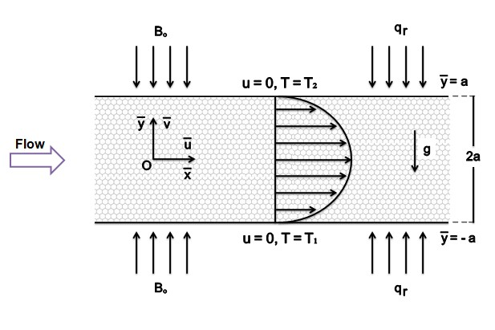Fig. 1.

For a poiseuille flow, flow must be streamline and parallel to the axis. So, $\overline{v}=0$. And the pressure at all points in a given cross-section is same. So, pressure gradient is constant $\frac{∂\overline{p}}{∂\overline{x}}$ = const = $\overline{P}$.

The governing equations for mass transfer, momentum and energy are given below, [1-4]

Continuity equation

$$\frac{∂ρ}{∂t}+∇.\left(ρV\right)=0$$

For a steady state, incompressible fluid the equation becomes,

$$\frac{∂\overline{u}}{∂\overline{x}}+ \frac{∂\overline{v}}{∂\overline{y}}=0$$

As $\overline{v}$ = 0, $\frac{∂\overline{u}}{∂\overline{x}}=0$ (1)

Momentum equation

$ρ_{f}\left[\left(V.∇\right)V\right]=-∇\overline{p}+μ∇^{2}V+ \vec{J}×\vec{B}-\frac{μ}{K_{1}}V+ρ_{f}β\left(T-T^{*}\right)g+∇.τ=0$ (2)

For Carreau Model, $μ= μ_{∞}+(μₒ-μ_{∞}){\left[1+{\left(\hat{λ}\dot{γ}\right)}^{2}\right]}^{\frac{(n-1)}{2}}$

Binomial expansion for ${(1+x)}^{n}$ is,

$${(1+x)}^{n}=1+nx+\frac{n(n-1)}{2!}x^{2}+\frac{n\left(n-1\right)(n-2)}{3!}x^{3}+…$$

If $x≪1$, we can neglect higher order terms and the expression becomes, ${(1+x)}^{n}≅1+nx$

For the case, $μ_{∞}=0, \hat{λ}\dot{γ}≪1$ the apparent viscosity becomes,

$$μ= μₒ\left[1+\frac{(n-1)}{2}{\left(\hat{λ}\dot{γ}\right)}^{2}\right]$$

$\dot{γ}=\sqrt{\frac{1}{2}\sum_{i}{\sum_{j}{{\dot{γ}}_{ij}{\dot{γ}}_{ji}}}}=\sqrt{\frac{1}{2}Π}$

$$Π=\frac{1}{2}tr{\left(grad V+{\left(grad V\right)}^{T}\right)}^{2 }⇒\dot{γ}=\frac{∂\overline{u}}{∂\overline{y}}$$

Component of extra stress tensor is given by,

$${\overline{τ}}_{ij}= μₒ\left[1+\frac{(n-1)}{2}{\left(\hat{λ}\dot{γ}\right)}^{2}\right]{\dot{γ}}_{ij}$$

We know that, $\vec{J}= σ_{f}\left(\vec{V}×\vec{B}\right)$ ⇒ $\vec{J}×\vec{B}= -σ_{f}{Bₒ}^{2}\overline{u}$

Now, substituting all the terms in (2) and using (1) we get,

$-\overline{P}+ 2μₒ\left[1+\left(n-1\right){\left(\hat{λ}\frac{∂\overline{u}}{∂\overline{y}}\right)}^{2}\right]\frac{∂^{2}\overline{u}}{∂{\overline{y}}^{2}}-σ_{f}{Bₒ}^{2}\overline{u}-\frac{μₒ\left[1+\frac{\left(n-1\right)}{2}{\left(\hat{λ}\frac{∂\overline{u}}{∂\overline{y}}\right)}^{2}\right]}{K_{1}}\overline{u}+ρ_{f}β\left(T-T^{*}\right)g=0$ (3)

Energy Equation

${\left(ρC_{p}\right)}_{f}\left[\left(V.∇\right)T\right]=k∇^{2}T+μΦ+\frac{1}{σ_{f}}\vec{J}.\vec{J}-∇.{\vec{q}}_{r}$ (4)

Viscous dissipation ($Φ)$ for 2-D is given by,

$$Φ=\frac{2}{3}\left[{\left(\frac{∂\overline{u}}{∂\overline{x}}-\frac{∂\overline{v}}{∂\overline{y}}\right)}^{2}\right]+{\left(\frac{∂\overline{u}}{∂\overline{y}}+\frac{∂\overline{v}}{∂\overline{x}}\right)}^{2}⇒Φ={\left(\frac{∂\overline{u}}{∂\overline{y}}\right)}^{2}$$

The radiative heat flux is given by Roseland approximation[5],

$$q_{r}=-\frac{4σ^{*}}{3k^{*}}\frac{∂T^{4}}{∂\overline{y}}$$

Expanding $T^{4}$ for mean value temperature $T^{*}$ by Taylor series, [6-7]

$$T^{4}={T^{*}}^{4}+4{T^{*}}^{3}\left(T-T^{*}\right)+6{T^{*}}^{2}{(T-T^{*})}^{2}+…$$

In this case temperature difference within a flow is taken to be very small. Square and higher-order terms of $\left(T-T^{*}\right)$ can be neglected. So, ${ T}^{4}≅{T^{*}}^{3}(4T-3T^{*})$

$$⇒q_{r}=-\frac{16σ^{*}{T^{*}}^{3}}{3k^{*}}\frac{∂T}{∂\overline{y}}$$

(4)⇒ ${\left(ρC_{p}\right)}_{f}\left[\overline{u}\frac{∂T}{∂\overline{x}}+\overline{v}\frac{∂T}{∂\overline{y}}\right]=k×\left(\frac{∂^{2}T}{∂{\overline{x}}^{2}}+\frac{∂^{2}T}{∂{\overline{y}}^{2}}\right)+μₒ\left[1+\frac{\left(n-1\right)}{2}{\left(\hat{λ}\frac{∂\overline{u}}{∂\overline{y}}\right)}^{2}\right]{\left(\frac{∂\overline{u}}{∂\overline{y}}\right)}^{2}$

$$+{ σ}_{f}{Bₒ}^{2}\overline{u}²-\frac{∂q_{r}}{∂\overline{y}}$$

Since temperature is changing in $\overline{y}$ direction only, $\frac{∂T}{∂\overline{x}}=0$

Dividing the whole equation by ${\left(ρC_{p}\right)}_{f}$ and substituting all terms we get,

$α\frac{∂^{2}T}{∂{\overline{y}}^{2}}+\frac{μₒ\left[1+\frac{\left(n-1\right)}{2}{\left(\hat{λ}\frac{∂\overline{u}}{∂\overline{y}}\right)}^{2}\right]}{{\left(ρC_{p}\right)}_{f}}{\left(\frac{∂\overline{u}}{∂\overline{y}}\right)}^{2}+\frac{1}{{\left(ρC_{p}\right)}_{f}}{ σ}_{f}{Bₒ}^{2}\overline{u}²-\frac{1}{{\left(ρC_{p}\right)}_{f}}\frac{∂q_{r}}{∂\overline{y}}=0$ (5)

The associated boundary conditions are [8-9],

At , , T=T1

At , , T=T2

The following are the non-dimensional quantities,

$$x=\frac{\overline{x}}{a}, y=\frac{\overline{y}}{a}, u=\frac{\overline{u}}{U_{m}}, P=\frac{a^{2}\overline{P}}{μₒU_{m}}, θ=\frac{T-T^{*}}{T_{1}-T^{*}}, K=\frac{K_{1}}{a^{2}}, λ=\frac{\hat{λ}U_{m}}{a},$$

$m=\frac{T_{2}-T^{*}}{T_{1}-T^{*}}$

Where, x and y are non-dimensional components, u is x component of dimensionless velocity, m is temperature scale, P is dimensionless pressure gradient, $θ$ is dimensionless temperature, $λ$ is dimensionless time constant, $U_{m}$ is the maximum velocity of fluid that occurs between two walls.

Using the above non-dimensional quantities we can get dimension-less form of (3) and (5) as,

$-P+2\left[1+(n-1){\left(λ\frac{∂u}{∂y}\right)}^{2}\right]\frac{∂²u}{∂y²}-\left[M+\frac{1+\left(\frac{n-1}{2}\right){\left(λ\frac{∂u}{∂y}\right)}^{2}}{K}\right]u+ \frac{Ra}{RePr}θ=0$ (6)

$\left(1+Rd\right)\frac{∂^{2}θ}{∂y^{2}}+ EcPr\left[1+\left(\frac{n-1}{2}\right){\left(λ\frac{∂u}{∂y}\right)}^{2}\right]{\left(\frac{∂u}{∂y}\right)}^{2}+ MPrEc u^{2}=0$ (7)

Where,

$$M=\frac{{ σ}_{f}{Bₒ}^{2}a^{2}}{μₒ}, Ra=\frac{\left(T_{1}-T^{*}\right)βga^{3}}{ϑα}, Re=\frac{aU_{m}}{ϑ}, Pr=\frac{ϑ}{α},$$

$$Rd=\frac{16σ^{*}{T^{*}}^{3}}{3k^{*}{\left(ρC_{p}\right)}_{f}α}, Ec=\frac{{U_{m}}^{2}}{C_{p}\left(T_{1}-T^{*}\right)}$$

**Approximate Analytic Solutions**

To obtain an analytical solution by homotopic approach, an initial estimates uₒ(y), $θ$ ₒ(y) and supplementary linear operators £u, £θ for velocity u(y), temperature $θ$ (y) can be pick out by higher order differential mapping [10]:

$\left.\begin{aligned}uₒ\left(y\right)= \frac{1-y^{2}}{2} \\ \\ θₒ(y)=\frac{\left(1+y\right)m+\left(1-y\right)}{2}\end{aligned}\right\}$ (8)

£u = u″(y), £θ = ″(y) (9)

The convergence control non-zero auxiliary parameters ℏu, ℏθ and nonlinear operators Nu, Nθ of velocity, temperature with embedding parameter ξ ∈ [0, 1] yields the following zeroth-order deformations:

$\left.\begin{aligned}\text{(1-ξ)£}\text{u}\text{[u(y, ξ) – uₒ(y)] = ξℏ}\text{u}\text{N}\text{u}\text{[u(y, ξ) , θ(y, ξ)]} \\ \text{(1-ξ)£}\text{θ}\text{[θ(y, ξ) - θₒ(y)] = ξℏ}\text{θ}\text{N}\text{θ}\text{[u(y, ξ) , θ(y, ξ)]} \end{aligned}\right\}$ (10)

$\left.\begin{aligned}For ξ=0, u\left(y, ξ\right)= uₒ\left(y\right), θ\left(y, ξ\right)= θₒ\left(y\right) \\ For ξ=1, u\left(y, ξ\right)= u\left(y\right), θ\left(y, ξ\right)= θ\left(y\right)\end{aligned}\right\}$ (11)

With

$\left.\begin{aligned}\text{N}\text{u}=-P+2\left[1+\left(n-1\right){\left(λ\frac{∂u\left(y,ξ\right)}{∂y}\right)}^{2}\right]\frac{∂^{2}u\left(y,ξ\right)}{∂y^{2}}-\left[M+\frac{1+\left(\frac{n-1}{2}\right){\left(λ\frac{∂u\left(y,ξ\right)}{∂y}\right)}^{2}}{K}\right]u\left(y,ξ\right)+ \frac{Ra}{RePr}θ\left(y,ξ\right) \\ \text{N}\text{θ}=\left(1+Rd\right)\frac{∂^{2}θ(y,ξ)}{∂y^{2}}+ EcPr\left[1+\left(\frac{n-1}{2}\right){\left(λ\frac{∂u(y,ξ)}{∂y}\right)}^{2}\right]{\left(\frac{∂u(y,ξ)}{∂y}\right)}^{2}+ MPrEc({u(y,ξ))}^{2}\end{aligned}\right\}$ (12)

The approximated solutions up to kth‐order approximation are expressed as:

$\left.\begin{aligned}u\left(y, ξ\right)= uₒ\left(y\right)+ \sum_{l=1}^{k}{u_{l}\left(y\right)}ξ^{l} \\ θ\left(y, ξ\right)= θₒ\left(y\right)+ \sum_{l=1}^{k}{θ_{l}\left(y\right)ξ^{l}}\end{aligned} \right\}$ (13)

**Results**

Figure 2(a) is drawn to analyze velocity profile distribution with the consideration of zero velocity slip for various Magnetic parameter (M) values with fixed values of n=2, $λ$ =0.2, K=0.2, m=0, Ra=1, Re=1, Rd=0.1, Ec=0.01, Pr=1, P= -5. Retardation occurs on velocity profile as shown in Fig. 2(a), because of the fact that Magnetic field is acted normally to flow direction in the absence of slip parameters.

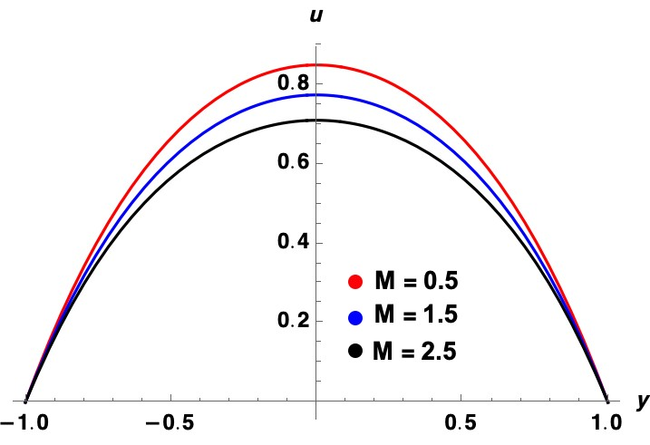

Fig. 2(a)

Figure 2(b) is drawn to analyze velocity profile distribution with the consideration of zero velocity slip for various Time constant ($λ$) values with fixed values of M=0.5, n=2, K=0.2, m=0, Ra=1, Re=1, Rd=0.1, Ec=0.01, Pr=1, P= -5. Velocity is increasing with the increase in time constant as shown in Fig. 2(b).

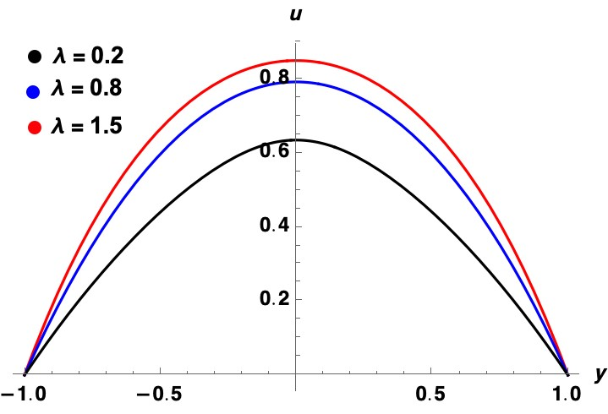

Fig. 2(b)

Figure 3 is drawn to analyze temperature distribution with the consideration of zero velocity slip for various with fixed values of M=0.5, $λ$ =0.2, n=2, K=0.2, m=0, Ra=1, Re=1, Rd=0.1, Ec=0.01, Pr=1, P= -5.

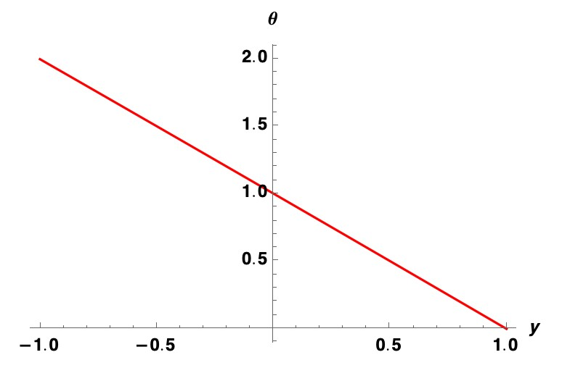

Fig. 3

**Conclusions**

An approximate analytical investigation of plane Poiseuille shear thinning fluid flow between two parallel horizontal walls via homotopic analysis. The walls are contained at different temperatures with no slip. The effects of various parameters are analyzed in graphical forms. The main findings are summarized as follows:

* The velocity profile decreases with an increase in magnetic field parameter but expecting reverse trend to be occur in temperature distribution.
* The velocity profile increases with an increase in time constant.
* Temperature decreases linearly with y co-ordinate.

**Future work**

* We will be extending this to Carreau nanofluid considering Stefan blowing.
* We have considered slip to be zero, in future we will analyze the effects including first and second order slip.
* We will plot the temperature distribution by varying the various parameters like Time constant, Magnetic parameter, Reynold’s number and Prandtl’s number etc.

**References**

[1] Sultan Z. Alamri, R. Ellahi, N. Shehzad, A. Zeeshan, Convective radiative plane Poiseuille flow of nanofluid through porous medium with slip: An application of Stefan blowing.

[2] M.Y.Malik, Iffat Zehra, S.Nadeem, Flows of Carreau fluid with pressure dependent viscosity in a variable porous medium: Application of polymer melt.

[3] Santiago Nicolas López-Carranza, Mathieu Jenny, Chérif Nouar, Pipe flow of shear-thinning fluids.

[4] R.Ellahia, A.Zeeshana, N.Shehzada, Sultan Z. Alamri, Structural impact of kerosene-Al2O3nanoliquid on MHD Poiseuille flow with variable thermal conductivity: Application of cooling process.

[5] S. Roseland, Astrophysik und Atom-Theoretische Grundlagen, Springer Verlag, Berlin, 1931 41–44.

[6] A.Sinha, G.C.Shit, Electromagnetohydrodynamic flow of blood and heat transfer in a capillary with thermal radiation, J. Magn. Magn. Mater. 378 (2015) 143–151.

[7] W. Ibrahim, B. Shankar, MHD boundary layer flow and heat transfer of a nanofluid past a permeable stretching sheet with velocity, thermal and solutal slip boundary conditions, Comput. Fluids 75 (2013) 1–10

[8] T. Fang, Flow and mass transfer for an unsteady stagnation-point flow over a moving wall considering blowing effects, J. Fluids Eng. 136 (2014) 71–103.

[9] G. Karniadakis, A. Beskok, N. Aluru, Microflows and Nanoflows: Fundamentals and Simulation, Springer, New York, 2005.

[10] R.A. Van Gorder, K. Vajravelu, On the selection of auxiliary functions, operators, and convergence control parameters in the application of the homotopy analysis method to nonlinear differential equations: a general approach, Commun. Nonlinear Sci. Numer. Simul. 14 (2009) 4078–4089